Nakayoshi Gakko
Arts and Crafts Committee

Class: Zou

Project: Kagami Mochi Boards

Material: Wood Board, Sandpaper
Pick up Board and Dowel

Dowels

Qty. Needed: (18) 6” x 6” square pieces

Instructions: 1) Cut each piece of wood into (18) 6" x 6" pieces. (See diagram) Please sand so there are no rough edges.

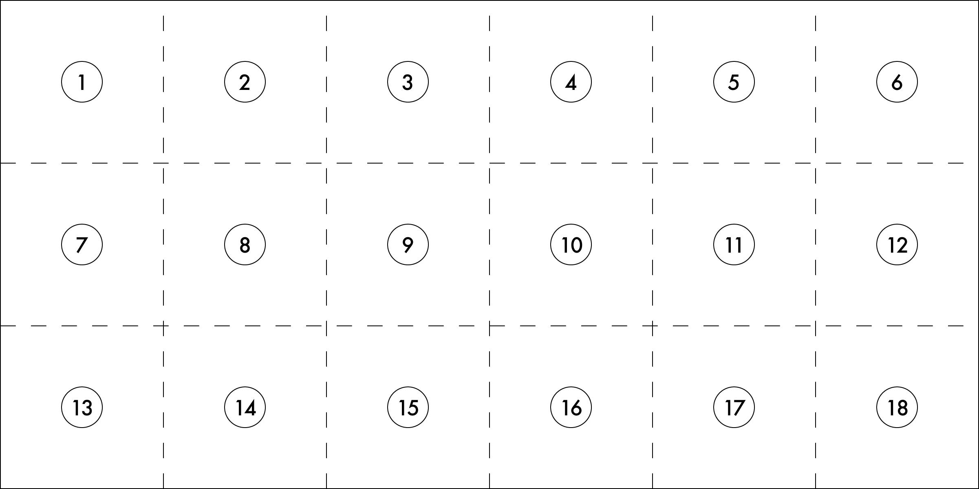

Due
2) Cut dowels into 2” lengths. Need 72 pieces total.

Due Date: Bring completed project with you on Maintenance I day prior to the start of the session. Please return sample.

Thank you in advance for your help. ☺

